Alliance of Independent Press Councils of Europe
26th AIPCE ANNUAL CONFERENCE
Bečići, Budva, Montenegro, 25-26 September, 2025
Do Press Councils have a future?

Speakers and Panelists
HOST OF THE CONFERENCE
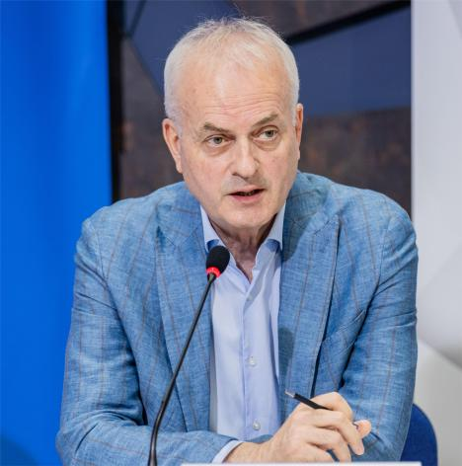 | Ranko VUJOVIĆ, Montenegro, is executive secretary of the Media council for self-regulation in Montenegro. He worked as a journalist for various media, from TV to radio, newspapers and weekly magazines. He ran the Association of Montenegro of commercial broadcasters. He was a member of the Council of the Agency for electronic media for 20 years and president of the same Council for ten years. He worked on many publications, studies.
SPEAKERS AND PANELISTS
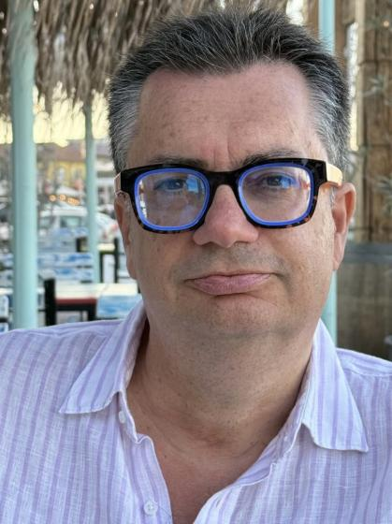 | Dr. Joan Barata, Portugal, is a human rights expert who particularly works on freedom of expression, media regulation, and intermediary liability issues. Currently he is Visiting Professor at the School of Law at Católica University in Porto. He was a Senior Fellow at The Future Free Speech project and the Program on Platform Regulation at the Stanford Cyber Policy Center. He has published many articles and books on these subjects. His work has taken him in most regions of the world, and he is regularly involved in projects with international organizations such as UNESCO, the Council of Europe, the Organization of American States or the Organization for Security and Cooperation in Europe, where he was the principal advisor to the Representative on Freedom of the Media.
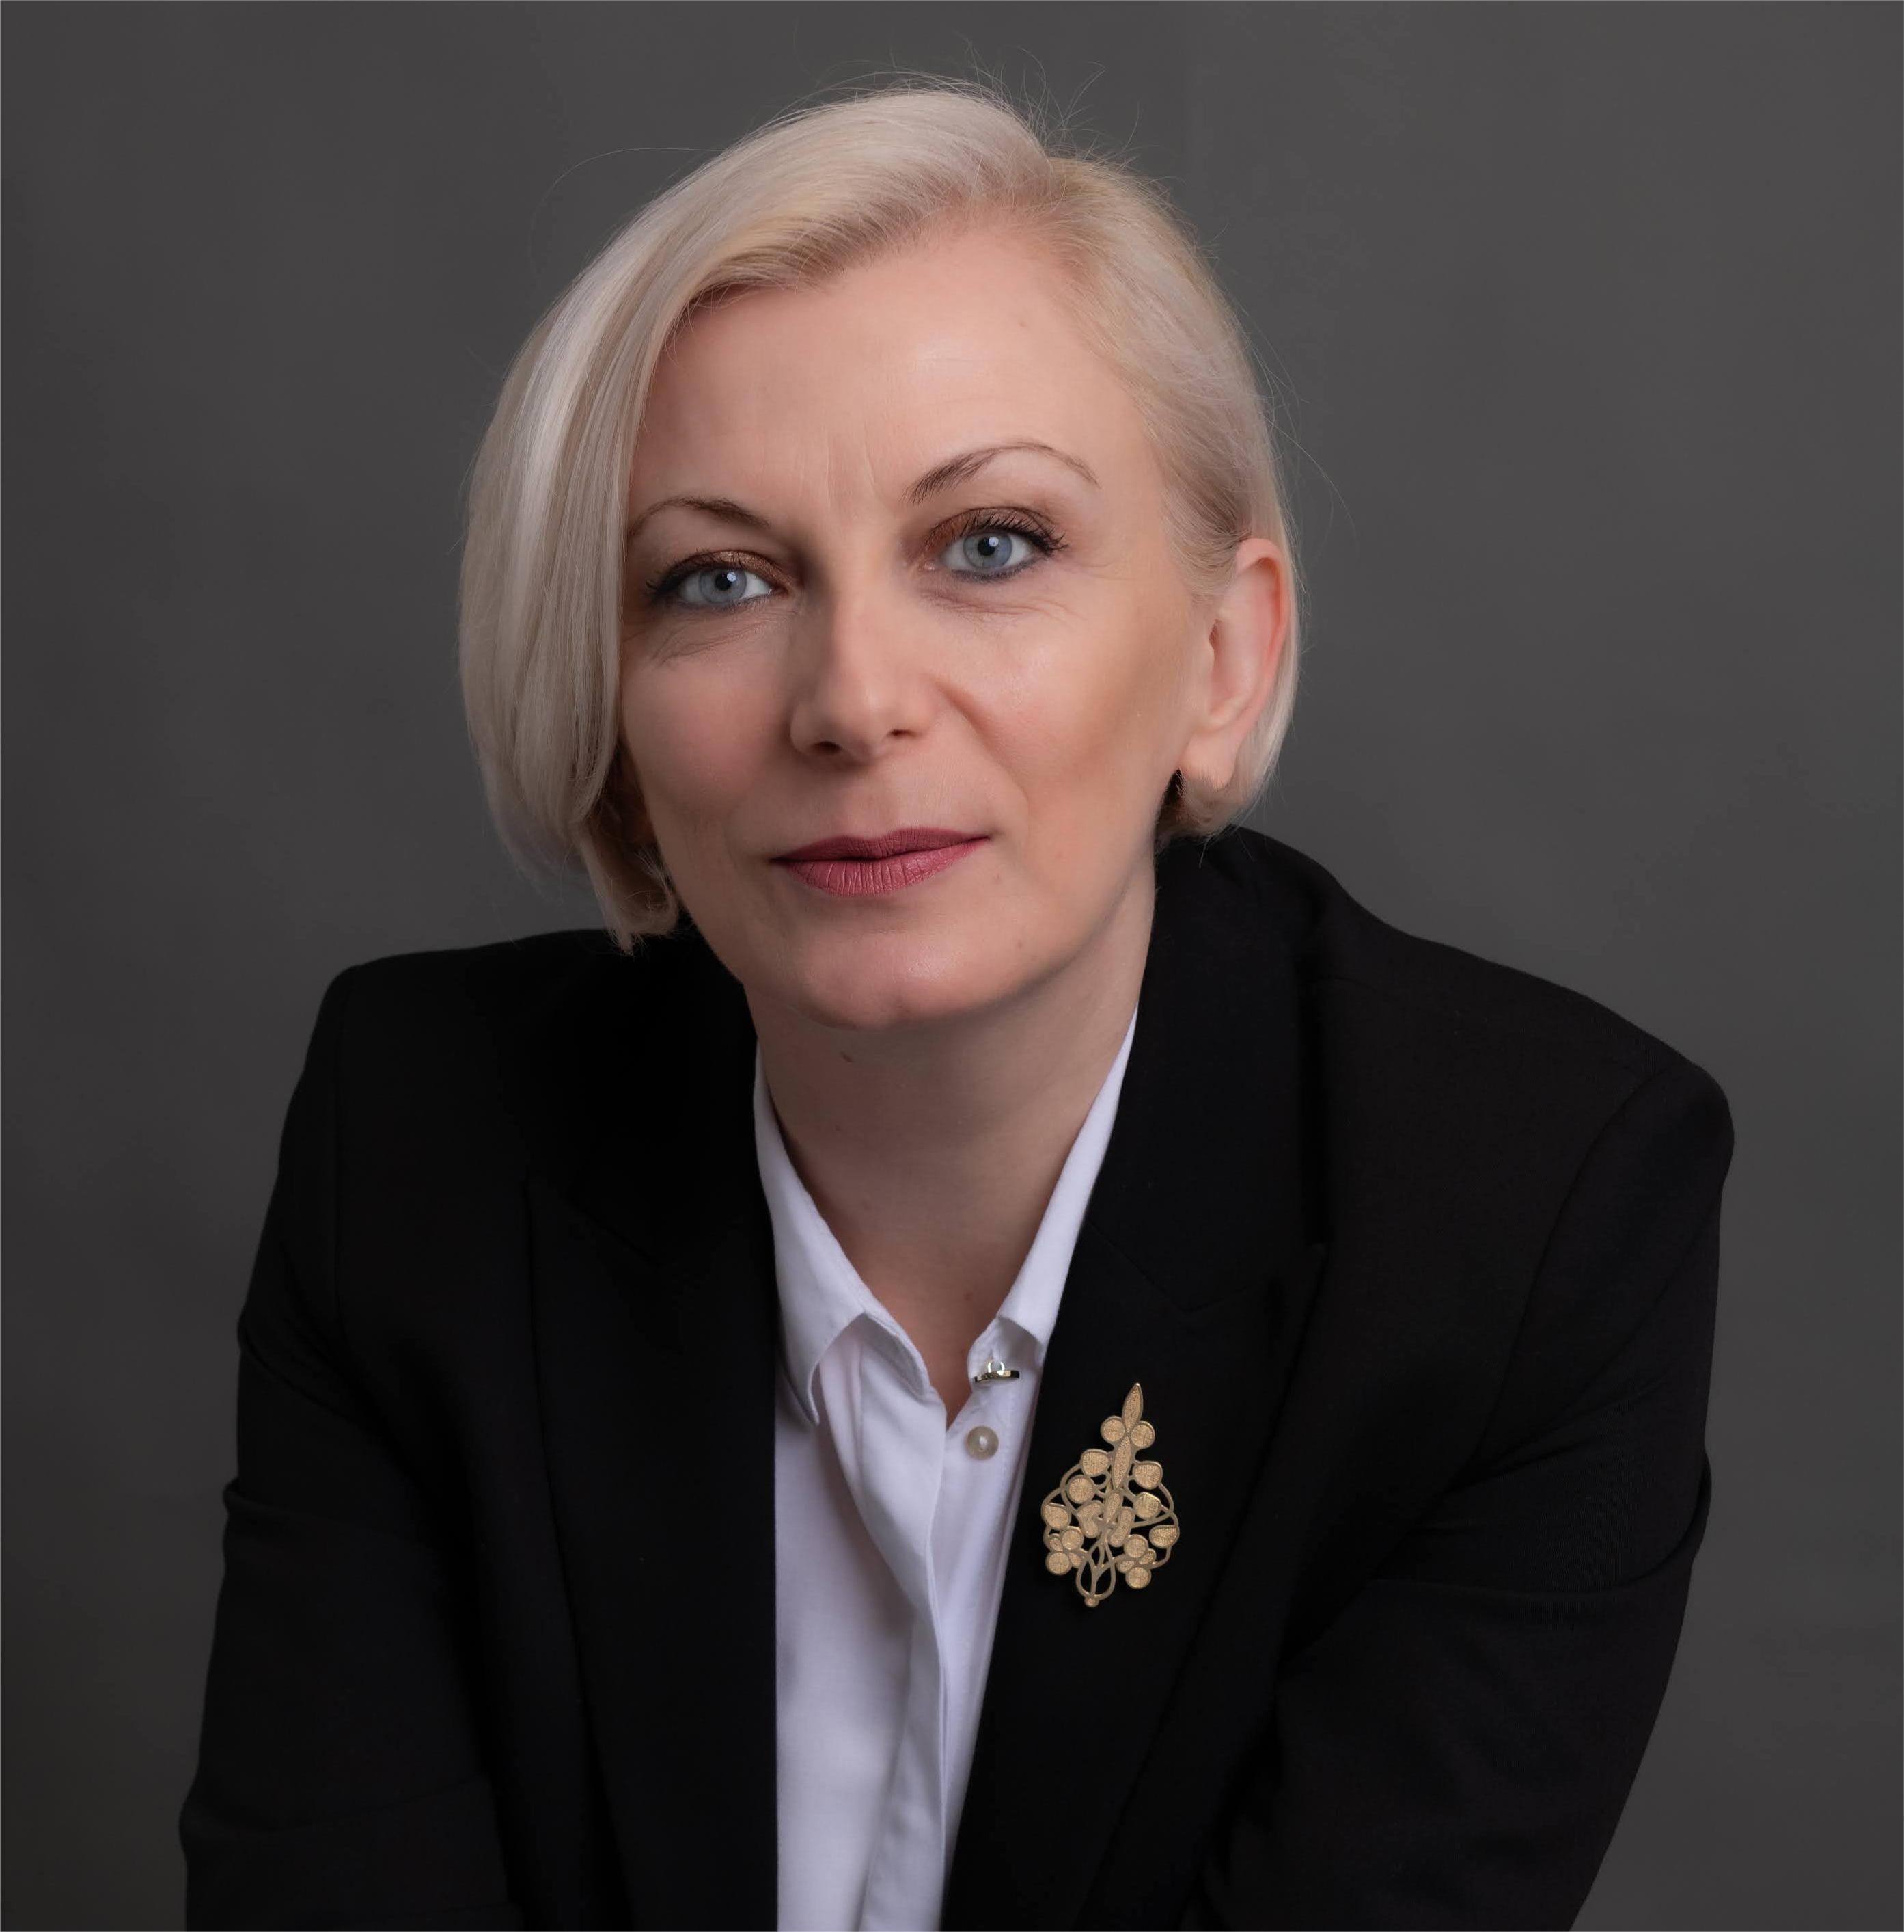 | Sunčica Bakić, Montenegro, is current Director of the Agency for Audiovisual Media Services of Montenegro (AMU). She works in the field of media regulation for 20 years, including previous position of Head of the Media Monitoring Department in Montenegrin regulatory authority. Holds MA in the field of independent regulation. Experienced in researching and collecting data in programming and advertising standards, as well as election processes. Particularly interested in the field of implementation freedom of expression rights and the right to privacy, hate speech and disinformation.
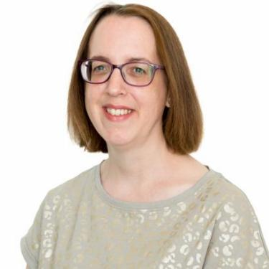 | Rosemary Douce, United Kingdom, is Head of Standards & Regulation at IPSO. Rosemary joined IPSO in 2018 and became Head of Standards in 2024. She is responsible for monitoring complaints, writing guidance for journalists and members of the public, and delivering training. She has a degree in English with Media Studies.
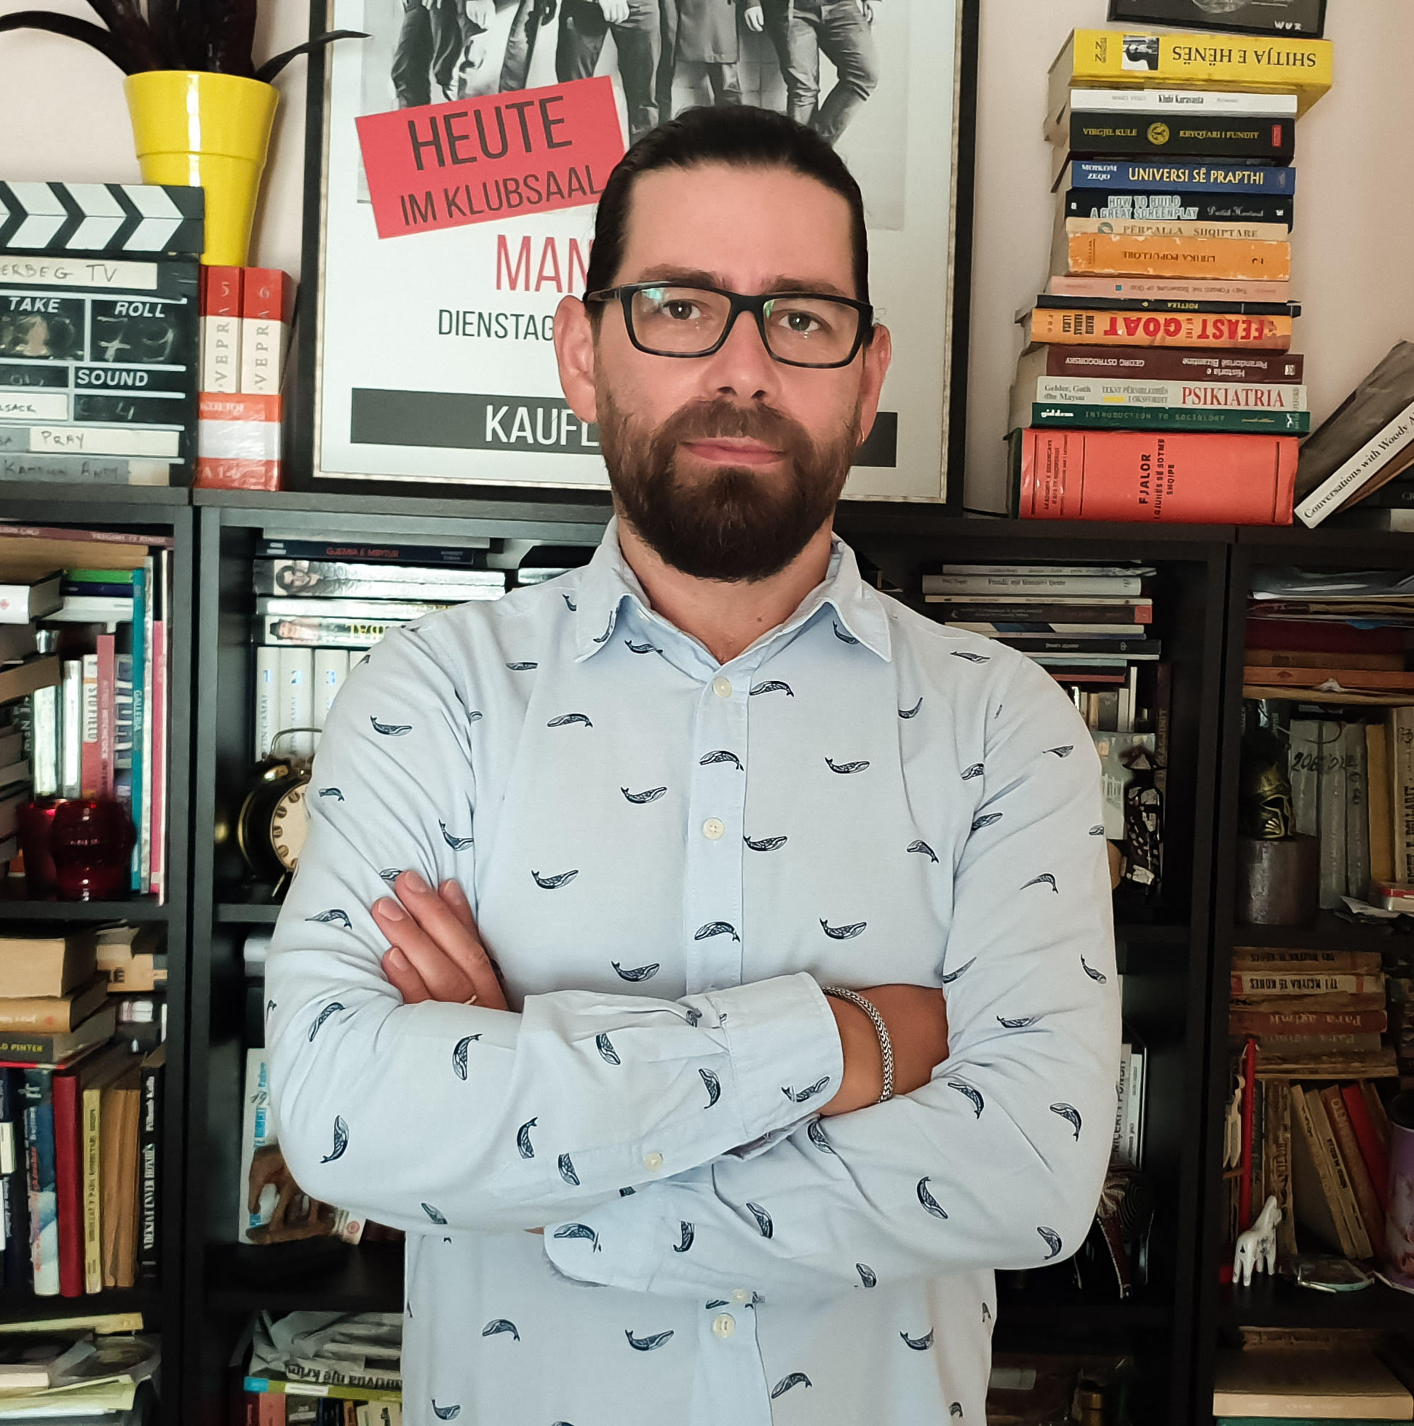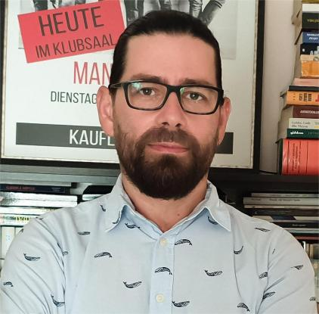 | Koloreto Cukali, Albania, is a prominent media expert, journalist, writer and director who has served as Chairman of the Albanian Media Council (KSHM) since 2017. With over two decades in journalism, he has worked as a columnist for major Albanian newspapers and as macro-editor of Shekulli during its peak years. He has directed radio programs for over 20 years, most recently at Top Albania Radio, and created innovative formats including the investigative show "Piranjat" and Albania's first ever sitcom "Radio-Radio."
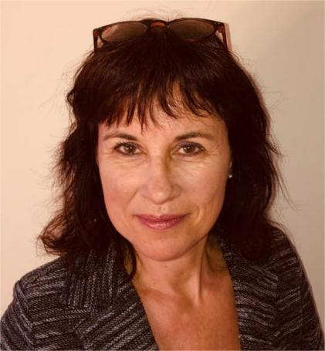 | Daphne Koene, The Netherlands, the secretary of the Netherlands Council of Journalism (Raad voor de Journalistiek) since 2001, author of the report Press Councils in Western Europe (AMB-uitgevers, 2008) and member of the Coordination Committee of the AIPCE. As part of phase four of the EU project 'Media Councils in the Digital Age', she recently conducted research into strengths and weaknesses of media councils in the European Union, which resulted in the report “Get on TRACK”.
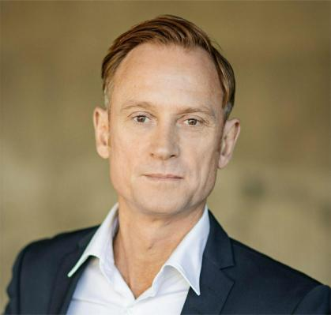 | Caspar Opitz, Sweden, is the Swedish Media Ombudsman since 2021. Prior to that he was the Managing Editor and Deputy Publisher of Sweden’s’ largest quality daily, Dagens Nyheter, where he worked for 21 years. He is an award-winning investigative journalist and former UK Bureau Chief.
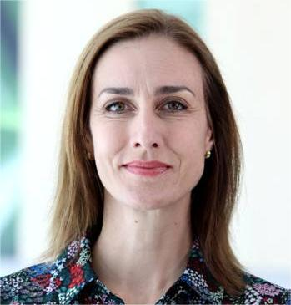 | Caroline Locher, Canada has been the Secretary General of the Quebec Press Council since 2017. Previously, she directed the professional association of journalists in Quebec. As a journalist, she worked at the BBC World Service in London, France24 in Paris, and at Canada's public broadcaster CBC/Radio-Canada in Montreal and Toronto. She studied business at McGill University (Bcom 2001) and Journalism at Concordia University (Graduate diploma 2005). She has also taught the journalism ethics course at the University of Montreal.
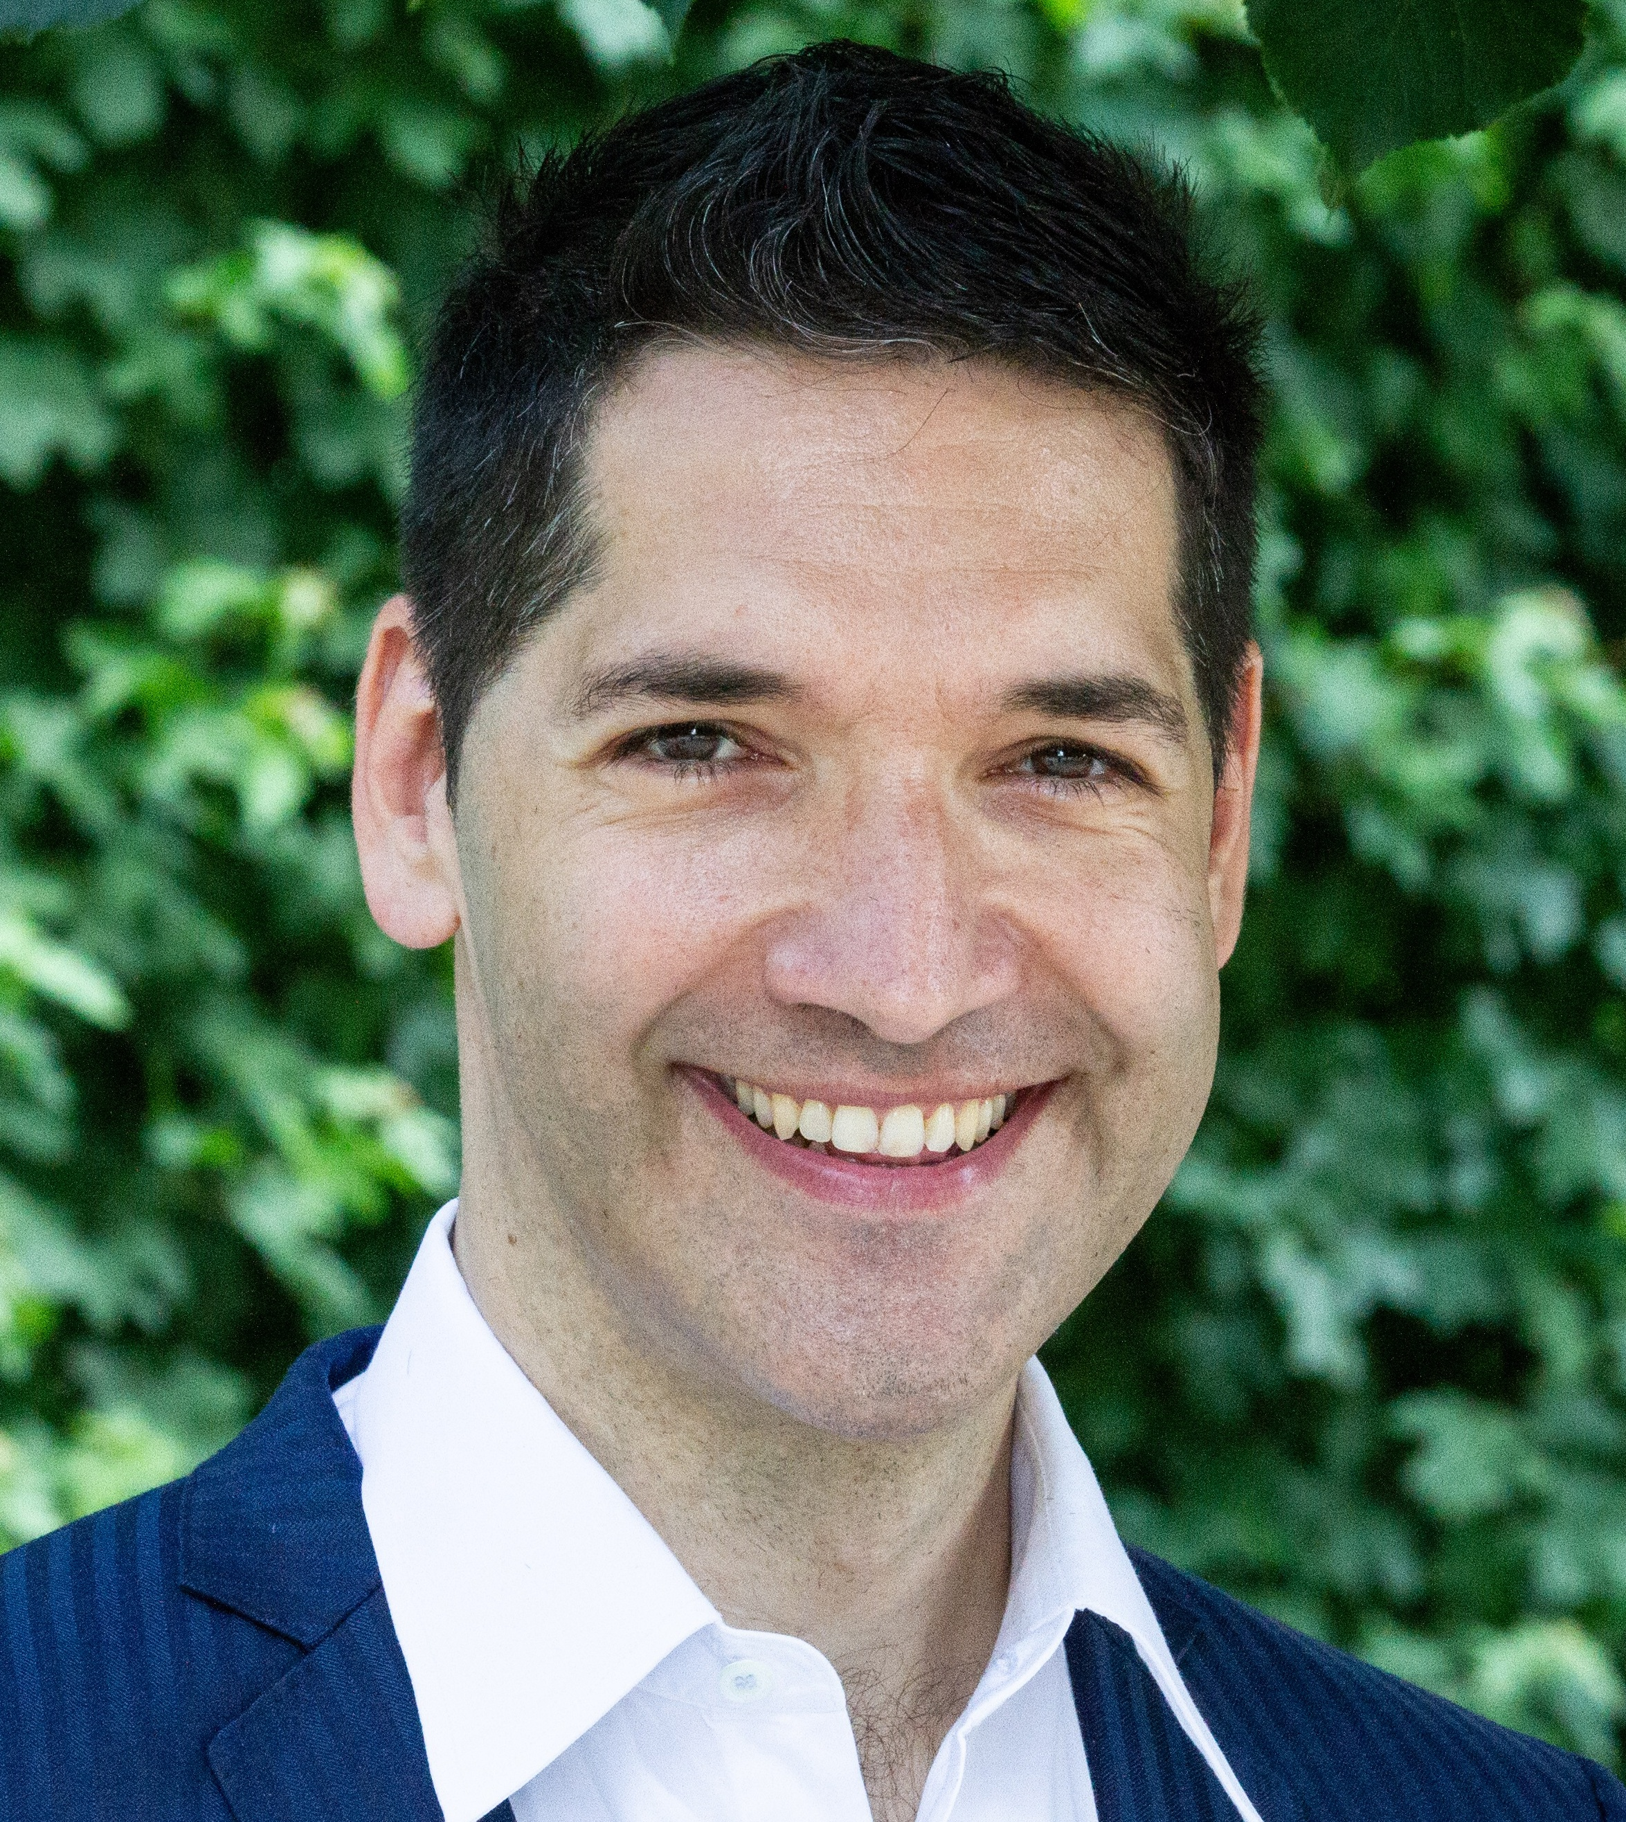 | Alexander Warzilek PhD, Austria, studied law at the Universities of Graz and Athens. He was a university assistant in Graz and Lucerne and conducted research at the Austrian Academy of Sciences. Since 2010, he has been the Managing Director of the Austrian Press Council. He also teaches media law and media ethics at several universities of applied sciences and the universities of Graz and Klagenfurt. He has published numerous specialized publications. Together with Prof. Helmut Koziol, he edited the international anthology "Personality Protection Against Mass Media" (published in 2005).
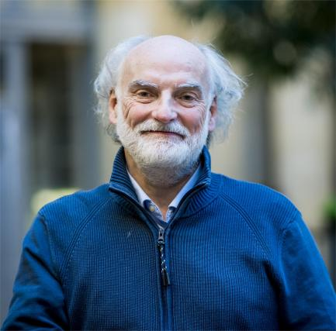 | Pieter Knapen, Belgium, is the secretary general and ombudsman of the Dutch speaking press council in Belgium (Raad voor de Journalistiek). He has been a journalist, editor and editor-in-chief for radio, television and online at the Dutch speaking public broadcaster in Belgium for more than 20 years.
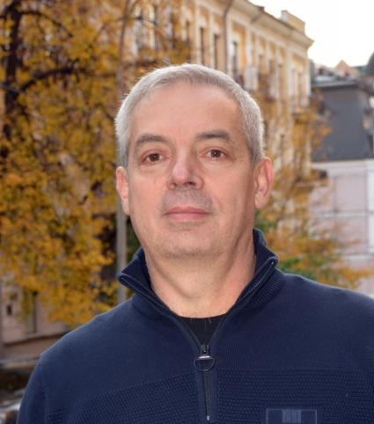 | Olekseii Pogorelov, Ukraine, is the president of the Ukrainian Association of Media Business, Member of Commission on Journalism Ethics. Up to 2009 he was managing several different media companies as CEO, then he was managing the association of media companies. Representing publishers of periodical media in the CJE. Member of the Association directors’ Committee of the WAN-IFRA. Member of the Public Councils of the Parliament's Committees, ans Public Council of the State Committee of Ukraine on radio and television.
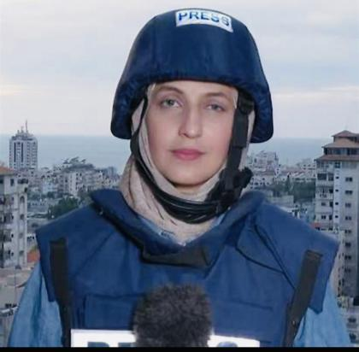 | Youmna El Sayed, Palestine, an internationally recognized journalist and public speaker, currently serving as the Al Jazeera English Correspondent in the Gaza Strip. With over ten years of experience reporting from the frontlines of conflict, I have worked with leading international media outlets including Al Jazeera English, TRT World, TRT Digital, RT, the Kuwait English Channel, CNA, and the Associated Press.
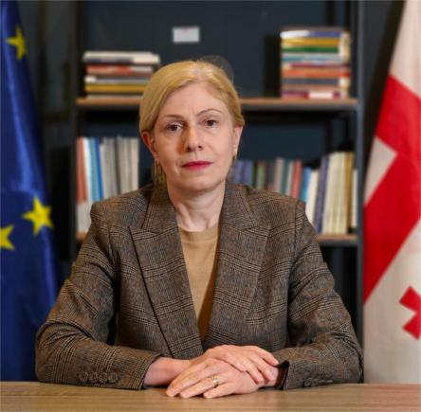 | Lia Chakhunashvili, Georgia, is Executive Director of the Georgian Charter of Journalistic Ethics. For 15 years, has worked on the USAID-supported media development programs in Georgia, implemented by IREX, in the positions of Chief of Party and Deputy Chief of Party. Lia contributed to the work of BBC World Service Trust, MDLF, IREX Europe) as Program Director, consultant and advisor. Chakhunashvili was Dean at Caucasus School of Media, in Caucasus University. She was a member of the Public Broadcaster Board of Trustees.
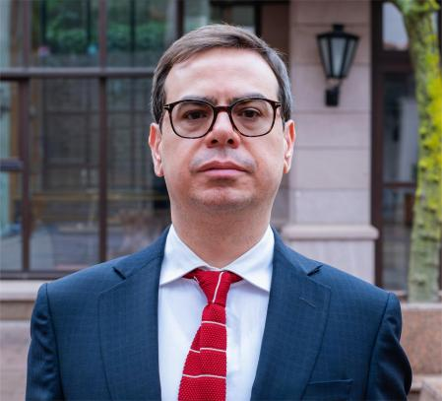 | Murat Önok, Türkiye, is an associate professor of criminal law working at a Private University in Istanbul. He has published nationally and internationally on matters related to criminal law, international criminal law, human rights, press freedom and media ethics. He was vice-president of Turkish Press Council for three terms, and is currently a board member. He was on the board of many NGOs and held various academic positions within the University and several professional organizations.
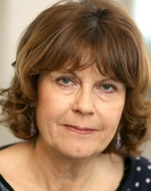 | Susan McKay, Ireland, Susan McKay is Ireland's Press Ombudsperson. She is an award winning author, journalist and commentator whose work was published in, among others, the New Yorker, the New York Times, the Guardian, and the Irish Times. Her specialist areas are the conflict in the North of Ireland, social issues and human rights. She is from Derry.
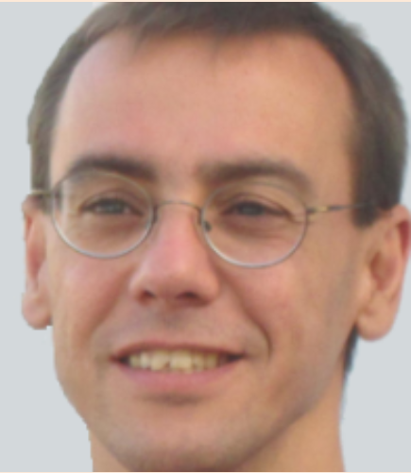 | Carlos Perez Maestro, European Commission, DG Connect, works in the Unit “Audiovisual and Media Services Policy” in DG CONNECT of the EC. This unit develops policy and legislation in the field of audiovisual media services, with a particular focus on the application of Audiovisual Media Services Directive and on policies to strengthen media freedom and pluralism. He has spent most of his career in DG CONNECT, where he has been dealing with telecoms regulation, broadband deployment policies, consumer issues, universal service, net neutrality, and online disinformation.
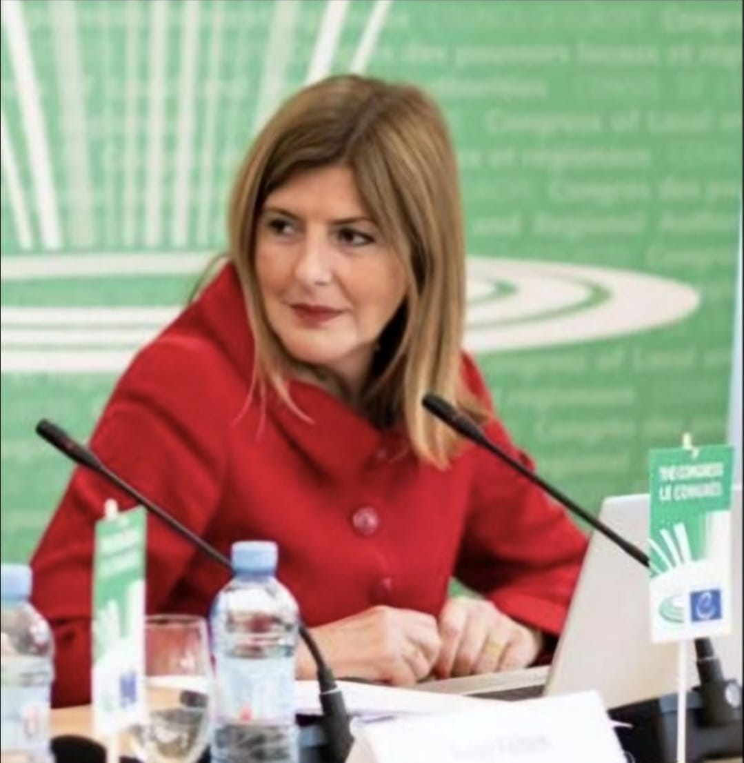 | Lejla Dervišagić, Council of Europe, has been the Head of the CoE Programme Office in Podgorica since April 2023. She previously led the CoE Programme Office in Skopje from 2021-2022. With over two decades of experience at the Council of Europe Headquarters in Strasbourg, she served in senior roles including Head of Unit in the Freedom of Expression and Media Division, as well as within the European Commission for the Efficiency of Justice (CEPEJ) and the Directorate of Political Affairs. From 1997 to 2001, she was Deputy to the Permanent Representative of Bosnia and Herzegovina to the CoE.
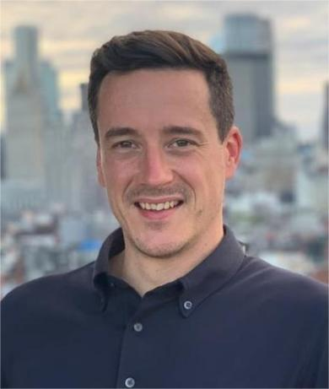 | Bertrand Mossiat, Reporters Without Borders, leads the development of Journalism Trust Initiative, a certification program for news publishers launched by the Paris-based media freedom organization, Reporters Without Borders. With a background in product, marketing, and sales across various press agencies and news publishers, Bertrand played a key role in the early growth of POLITICO Europe in Brussels and in Paris.
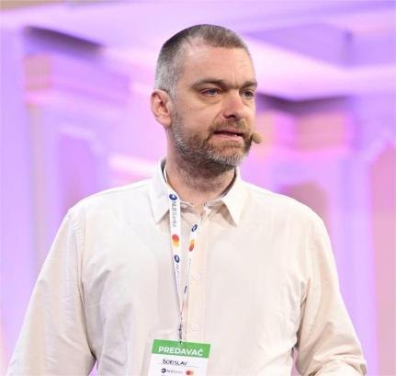 | Borislav Vukojević is an associate professor at the University of Banja Luka’s Faculty of Political Sciences and a UNESCO consultant focused on the responsible use of AI in media and education. He designs and delivers AI trainings and lectures across the Western Balkans - introducing generative AI to teachers and newsrooms and advocating a human-centred, ethical approach. He writes about AI tools in the newsroom and methods for detecting disinformation, and appears at regional conferences. Under the “Boro GPT” moniker, he curates practical AI insights on social media and advises organizations on adopting AI responsibly.
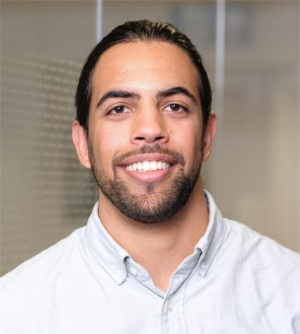 | Tom Spencer, United Kingdom, is the Regulatory Manager at Impress, primarily responsible for managing complaints and investigations into potential breaches of the Impress Standards Code, as well as administering Impress’ dispute resolution services. He also acts as secretariat for Impress’ Code Committee, contributing to the development of supplementary guidance for publishers and reviews of the Standards Code. Previously worked at Opus 2, assisting lawyers on the use of a cloud-based platform for litigation and arbitration cases. This experience prompted him to undertake the Legal Practice Course at BPP law school.
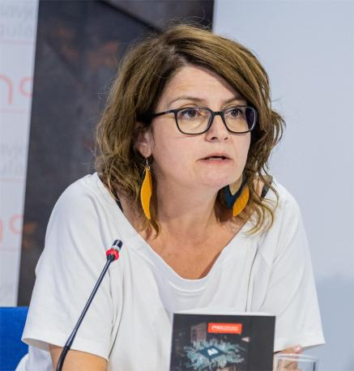 | Paula Petričević, Montenegro, is a philosopher, publicist, feminist and peace activist. Currently a PhD candidate at the Faculty of Political Science at University of Belgrade. Paula has worked as a program director for the Center for Civic Education and as a lecturer at Women's Studies organized by ANIMA. She teaches philosophy at the Gimnazija Kotor and works as an ombudswoman for "Vijesti" and "Monitor". She has published articles and book chapters on gender issues, the history of the women's movement in Montenegro, and media ethics.
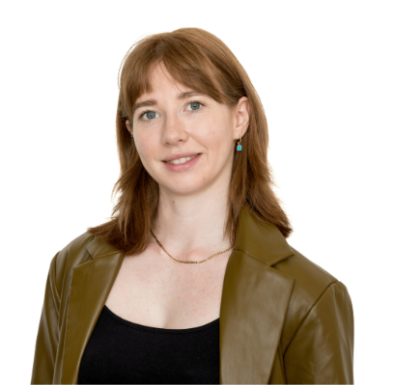 | Alice Gould, United Kingdom, prior to joining IPSO, Alice Gould had an international career, working at non-governmental organisations in the US and the Republic of Georgia to promote human rights, as well as spending a year teaching English in China. Alice holds a master’s degree in Human Rights and an undergraduate degree in Law with European Law. Alice joined IPSO as a Complaints Officer in 2019 and took on the role of Head of Complaints in 2023.
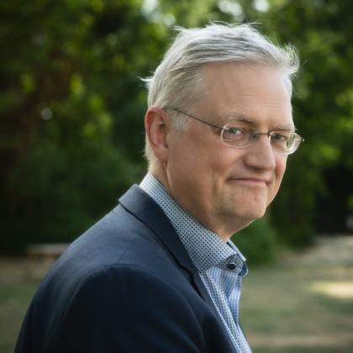 | Tim Pauwels, Belgium, is the vice-chairman of the Flemish Council of Journalism. He is the current editor of the Check&Investigative section of the VRT News Redaction. This redaction publishes on disinformation, technology and artificial intelligence and does investigative reporting on all subjects. Tim also served a five year term as News Ombudsman for VRT, the Flemish Public Broadcaster. Pauwels is also linked to the NGO initiatives www.decheckers.be and www.Factcheck.Vlaanderen, and is also a visiting lecturer at the KU Leuven on journalistic ethics KU Leuven who's who - Tim Pauwels.
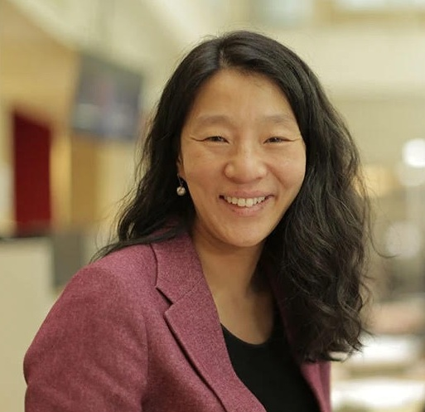 | Anne Weider Aasen, Norway, is an editor in the Norwegian public broadcaster NRK. She has been head of the Press Council of Norway since 2020, and chairs the monthly meetings of the Council. She has also worked 27 years in the Norwegian private broadcaster TV 2, in which she has held different positions as a journalist and as an editor.
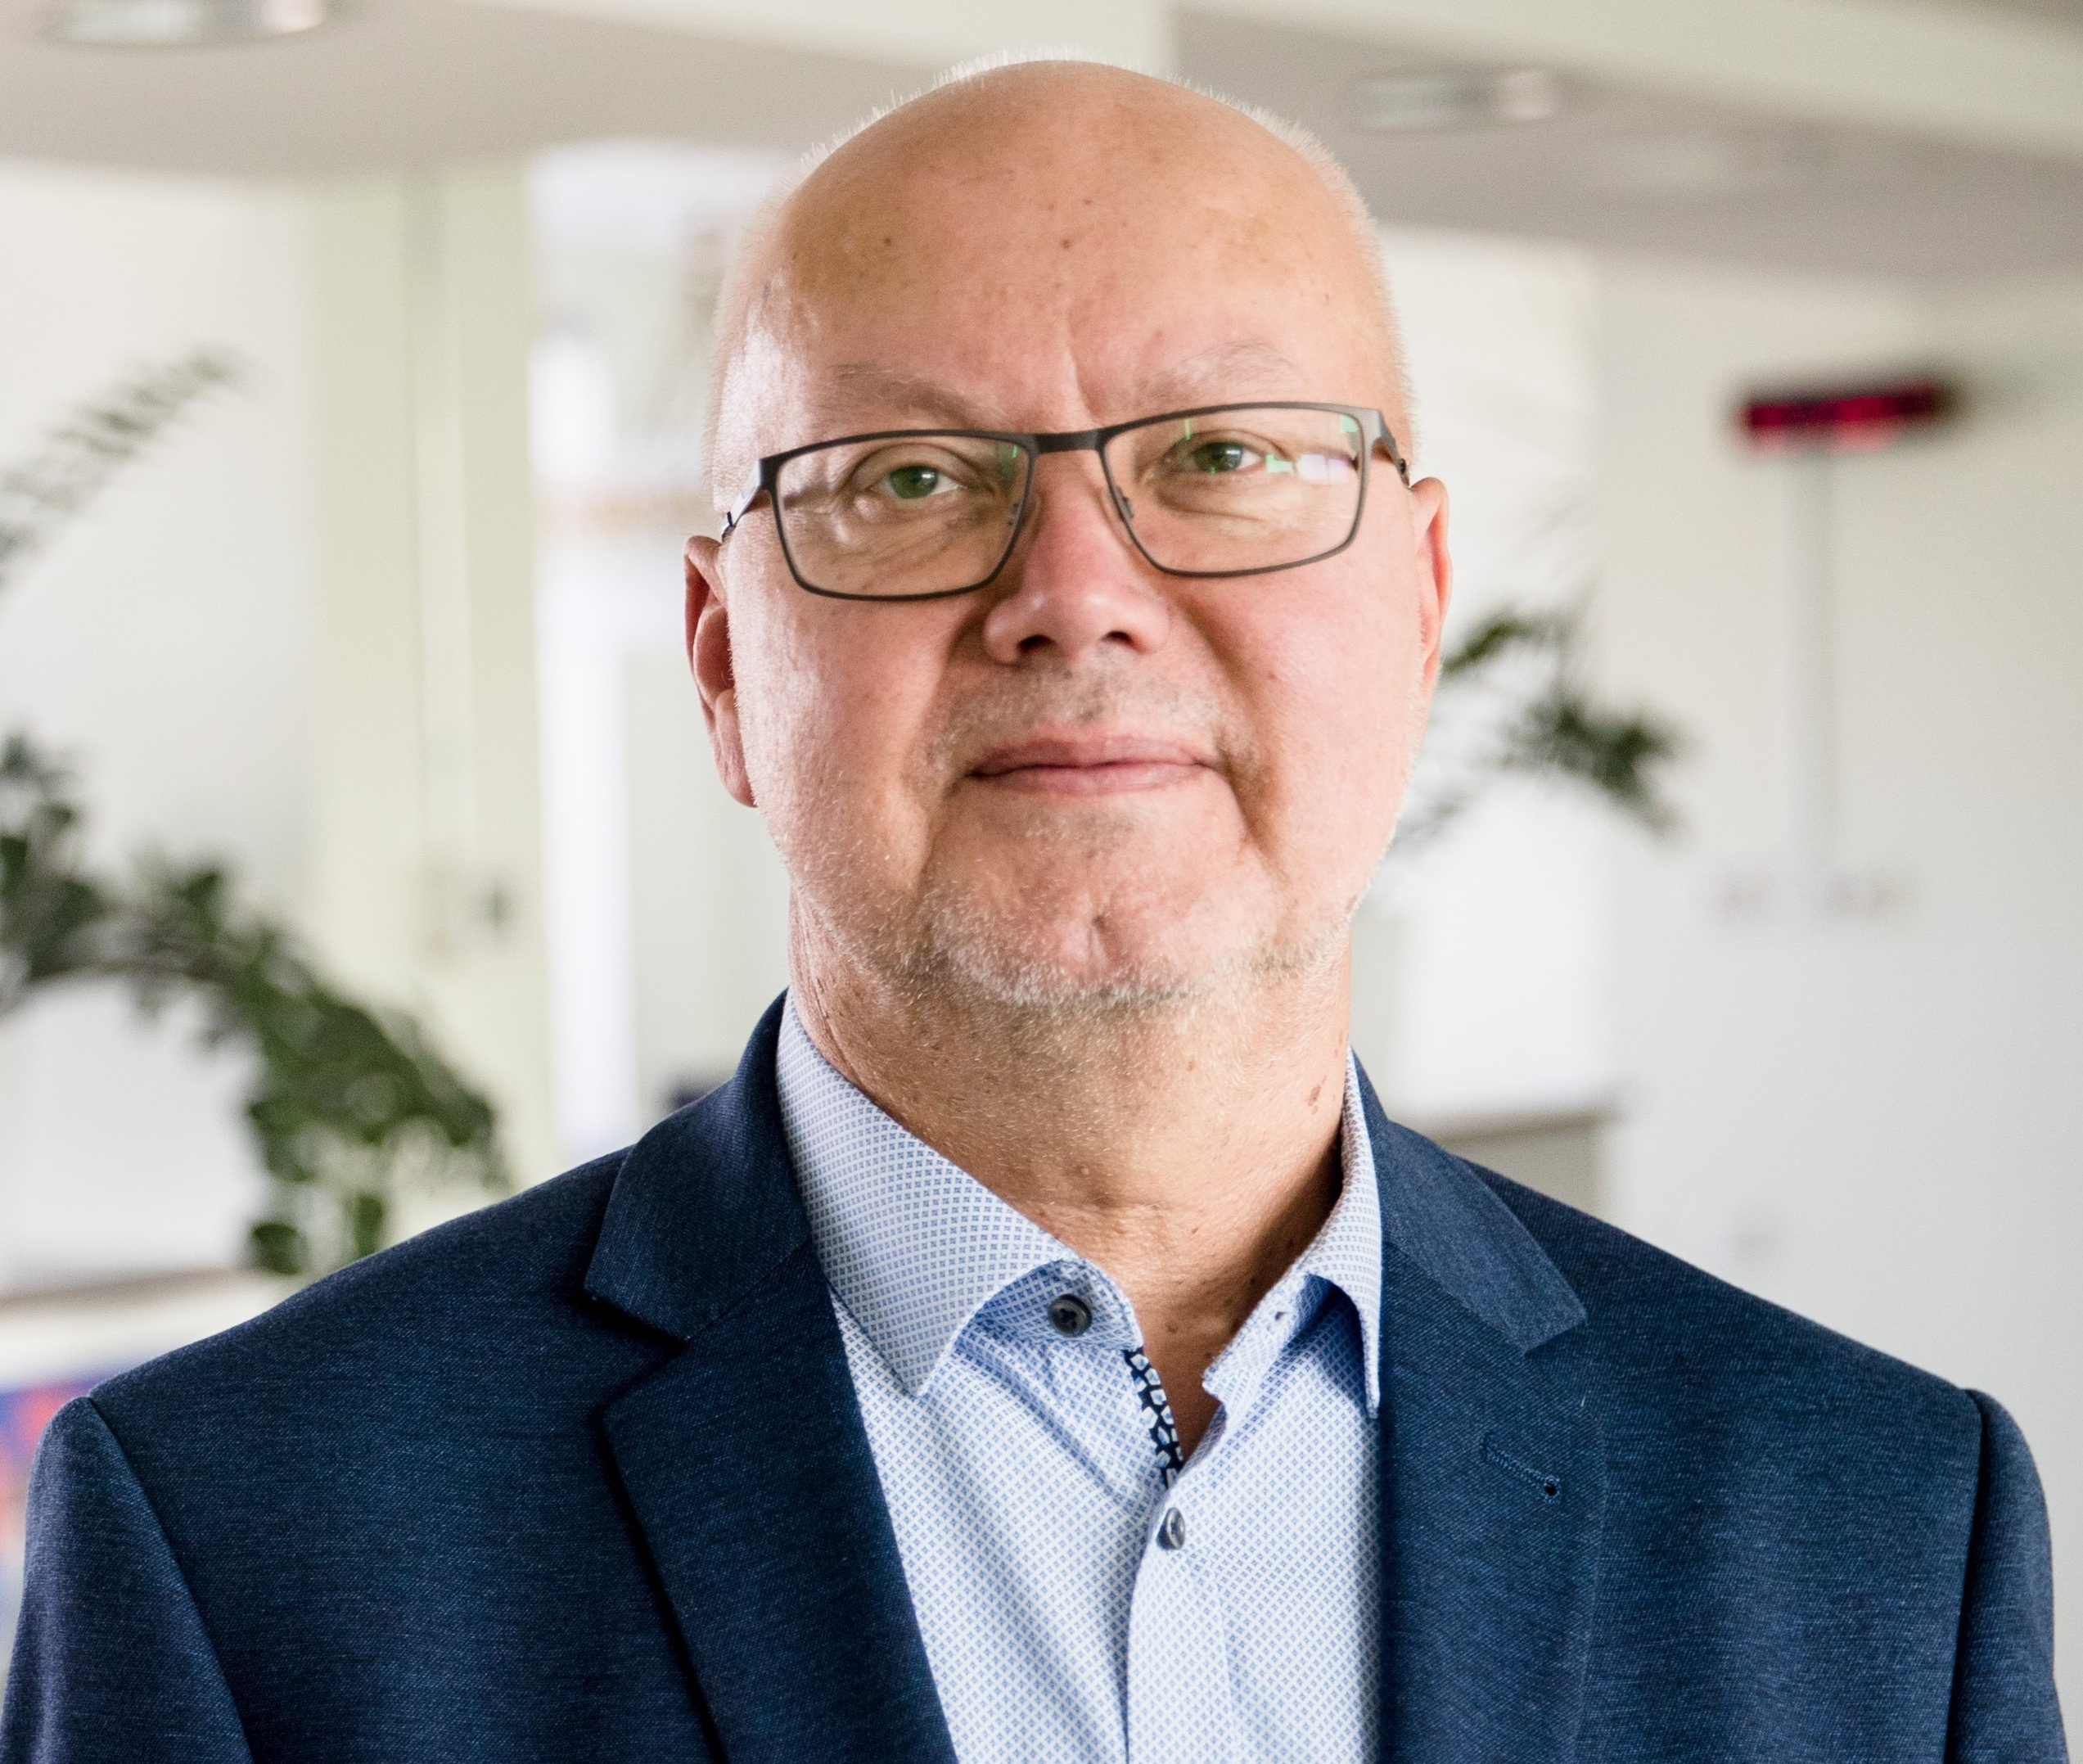 | Tarmu Tammerk, Estonia, is deputy chairman of the Press Council of Estonia and ombudsman at the Estonian Public Broadcasting Company. His previous career of more than 15 years includes journalistic work in newspapers, radio, TV as well as in media NGOs. He belonged to the working group that drafted the Estonian code of journalism ethics.
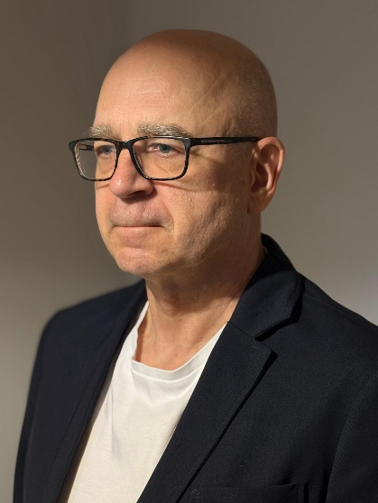 | Eero Hyvönen, Finland, has worked as the chair of Council for Mass Media in Finland since 2020. Prior to that he has held several senior positions in Finnish Media outlets, mainly as editor-in-chief at nationwide news media (Channel Four News and Helsingin Sanomat), but also at the metropolitan commercial radio station Radio City and Ylioppilaslehti, a national student magazine. He has served as development manager for the public broadcaster YLE's nationwide regional operations at the end of the 2010's. Eero started out as a reporter and features writer back in the 1980's. He is a lawyer by education (LLM, University of Helsinki).
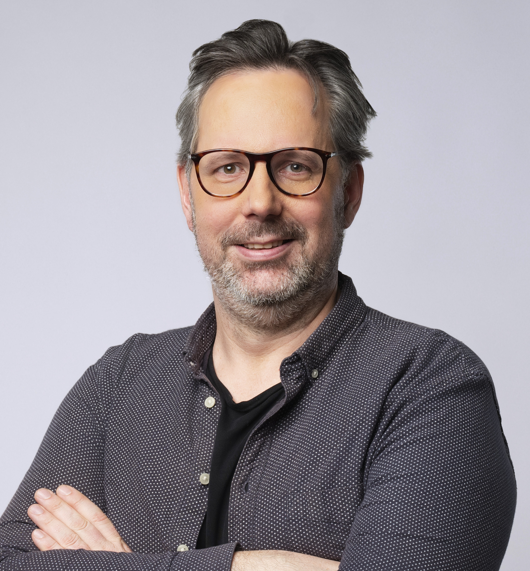 | Yann Guégan, France, is a French journalist specialized in editorial innovation and digital journalism. He works at Contexte, a website reporting on French and European public policy. He develops interactive infographics and designs digital tools to facilitate the work of journalists. Having started his career in 2001, he has worked for numerous media outlets such as Rue89 (where he was deputy editor-in-chief), Libération, and Télérama. He is also the deputy president of the French press council, the Conseil de déontologie journalistique et de médiation (CDJM), a self-regulatory body for journalistic ethics that he helped found in 2019. In this capacity, he regularly speaks at journalism schools.

